Received: XX XXX 2026
Accepted: XX XXX 2026


Available online: XX XXX 2026

RESEARCH ARTICLE
Research Area, Applied Sciences, Engineering, Pure Sciences.

TITLE (Max 15 words)

Author 11,2| Author 21| Author 31*| (Please include ORCID hyperlinked IDs)
¹Department of xxxxxxxxxxxxxxxxxx, Faculty of xxxxxxxxxxxxxxxxxxxxxx, xxxxxxxx University, City, adress
² Department of xxxxxxxxxxxxxxxxxx, Faculty of xxxxxxxxxxxxxxxxxxxxxx, xxxxxxxx University, City, adress

Correspondence
Corresponding author
Email:

ABSTRACT. (Maximum 250 words - English)
keywords: (Maximum 7 keywords, corroborate existence in the UNESCO thesaurus).

RESUMEN. (Máximo 250 palabras – español).
Palabras clave: (Máximo 7 palabras clave, corroborar su existencia en el tesauro de la UNESCO).

| INTRODUCTION

Must guide the reader from the general context of the problem down to the specific knowledge gap that this paper intends to fill; also must include a short state of the art with a contemporary literature review using high impact journal sources. (Due to ease comprehension for the readers, please, do not introduce “State of the Art” as sub-section)

The introduction should explicitly conclude by stating the primary objective and scope of the presented research; connecting directly with the next sections of the paper).

| DESIGN AND METHODOLOGY

Must be described with sufficient rigor to allow any expert in the field to replicate the study exactly; for this purpose, please provide precise details on experimental design, mathematical models, analyzed variables, software used (including its specific version), and technical specifications of equipment or reagents.

  - | Subsection 1.

Breaking down this section using logical subheadings is highly encouraged if the process involves distinct phases (e.g., 2.1 Material synthesis, 2.2 Computational simulations,).

  - | Subsection 2.

  - | Subsection 3.

  - | Subsection 4.
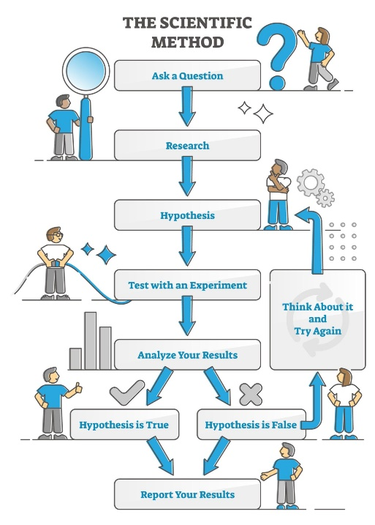

FIGURE 1. Example of a methodological flowchart for papers to submit. (Source: VectorMine / Getty Images).

Guidelines for figures:

Resolution and Format: All figures must be submitted in high resolution (minimum 300 DPI). Preferred formats are vector files (.pdf, .eps) for diagrams, flowcharts, and plots, or high-quality .png or .tiff files for photographs and complex simulations. Avoid using compressed .jpg files or software screenshots.

Text and Legibility: All text, labels, and numbers within the figures must be perfectly legible. The font size inside the figure should be comparable to the main text font size when compiled (do not use tiny or pixelated fonts). Ensure high contrast between text and the background.

Legends and Labels: Axes in graphs must be clearly labeled with the respective variable name and its measurement units enclosed in parentheses—for example, Temperature (°C), Time (s), or Concentration (mol/L).

Standalone Understanding: Every figure must be auto-explicable (standalone). This means the reader should understand the graphic by reading only its caption and legend, without strictly needing to look at the main text.
Numbering and Captions: Figures must be numbered sequentially using Arabic numerals (e.g., Figure 1, Figure 2). The caption must be placed below the figure, starting with a brief descriptive title followed by minimal necessary context.
Copyright and Originality: Figures must be original. If a figure is adapted or reproduced from a previously copyrighted source, the authors are entirely responsible for obtaining formal permissions and must explicitly state the source at the end of the caption (e.g., "Source: Adapted from Smith et al. (2022)" or “Source: Adapted from [38]”).

Guidelines for equations:

Native Equation Editor: All mathematical equations, expressions, and variables must be inserted using the native Microsoft Word Equation Editor (accessible via Insert > Equation). Under no circumstances should equations be inserted as images, screenshots, or plain text symbols.

Font and Style: Equations must be formatted using Cambria Math (the default font of the Word Equation Editor) or the primary font designated by the template.

Placement and Alignment:

Display Equations: Major or standalone equations must be placed on a separate line, centered on the page.

In-line Equations: Short mathematical expressions or single variables mentioned within a paragraph must be inserted using the inline equation feature to maintain consistent line spacing.

Sequential Numbering: All display equations must be numbered sequentially using Arabic numerals enclosed in parentheses, aligned to the right margin of the page (e.g., (1), (2)).

Formatting with Tables (Recommended Layout): To ensure perfect horizontal alignment (centered equation and right-aligned number), authors must use a hidden 3-column or 2-column table with invisible borders:

Left/Center Column: Centered text alignment for the equation.

Right Column: Right text alignment for the equation number.

Citation in Text: Every numbered equation must be explicitly cited and discussed in the body text using its number enclosed in parentheses—for example: "Substituting the values into Equation (1), we obtain..." or "The velocity profile is defined by (Eq. 1).

$$\hat{H}Ψ_{(θ,ρ,z)}=EΨ_{(θ,ρ,z)} (Eq. 1)$$

| RESULTS & DISCUSSION

Results:
Clear, objective, and logical presentation of findings through the efficient use of text, tables, or figures. Avoid redundancy (if data is presented in a table, the text should not list the numbers again, but rather highlight trends, critical points, or anomalies).
Discussion:
This is the most critical section for peer reviewers. It must critically contrast the obtained results with those reported by other authors in the State of the Art. What do these data mean? Do they support or contradict current theories? Why?

Guidelines for tables:

Format and Structure: Tables must be created using the native table tool of your word processor (MS Word Insert > Table). Under no circumstances should tables be submitted as images, screenshots, or plain text separated by tabs/spaces.
The Three-Line Aesthetic (Aesthetics): To maintain professional layout standards, tables should feature a clean, minimalist design using horizontal lines only. Vertical lines are strictly forbidden. As a general rule, a standard table should have only three main horizontal rules:
A top border (above the column headers).
A middle border (separating the headers from the data cells).
A bottom border (at the end of the data rows).
Numbering and Captions: Tables must be numbered sequentially using Arabic numerals (e.g., Table 1, Table 2). The caption must be placed above the table, starting with a brief descriptive title followed by minimal necessary context.
Text and Alignment:
Text within cells should be smaller than the main body text (typically 9 or 8 pt) to fit data comfortably.
Text columns should be left-aligned, while columns containing numerical data must be center-aligned or right-aligned to align decimal points cleanly.
Units of Measurement: All numerical data must include its respective measurement units clearly stated in the column headers enclosed in parentheses—for example, Density (g/cm³) or Yield (%)—rather than repeating the unit in every single cell.
Abbreviations and Notes: Any abbreviations, symbols, or significance markers (such as p-values) used within the table must be explicitly defined using a footnote placed immediately below the bottom border of the table.

Citation in Text: Every table included in the manuscript must be explicitly cited and discussed in the body text before its visual appearance (e.g., "The kinetic properties are summarized in Table 1.").

TA B L E 1 Example of a table in the paper to submit
Sample code | Melting point range (°C) | Rate constant at 25°C (M⁻¹ *s⁻¹)* | Rate constant at 100°C (M⁻¹ *s⁻¹)*
SYN-01 | 35-37 | 0.320 | 0.645
SYN-02 | 152-155 | 0.980 | 2.05
* Rate constants determined by ¹H-NMR kinetic experiments in CDCl₃ using TMS as internal standard for chemical shifts, and residual solvent signal as internal standard for relative integration.

| CONCLUSIONS:
Must be direct, concise deductions grounded strictly in the presented results. This section should not be a summary of the paper.
Must unequivocally answer the primary objective stated in the Introduction. Including a brief reflection on study limitations or proposing future research directions is highly recommended.

| ACKNOWLEDGMENTS, FUNDING AND AUTHOR CONTRIBUTIONS:
Acknowledgments are optional; it is a space to recognize support from laboratories, technicians, or colleagues who do not meet the co-authorship criteria.
Funding recognition is mandatory; explicitly declare the institution, project name or grant code that financed the research. If did not received external funding, declare: “This research received no external funding”.
Author contributions
Specify the role of each author using the international CRediT taxonomy (e.g. Jane Doe: Conceptualization and supervision; Wally White: Methodology design and writing).

| REFERENCES:
Style of citation must be on IEEE format; DOI as hyperlinked URL must be included where is possible. At least 70% of the references must belong to indexed articles or books. Please minimize the use of undergraduate theses, general websites, social networks or blogs.
References must be located in the text as Arabic numbers enclosed in the order they appear in the text [1], [2], etc.
The bracketed number must be placed inside the sentence punctuation (before the period or comma), leaving a space before the opening bracket; once a number has been assigned (e.g. [3]), that same number must be used for all subsequent citations of that specific source throughout the entire manuscript.

| Journal Articles:
[1]. A. B. Author, C.D. Author, and E.F. Author, “Title of the article”, Abbrev. Title of Journal, vol. no. X, pp. XXX-XXX, Year. DOI: https://doi.org/10.xxxx.xxxxx/xxxxxx.
[2]. C.A. Michelin and O.A. Uva, “Advanced molecular docking simulations for the evaluation of novel organic biomaterials”, IEEE Trans. Mol. Cybern., 66, 25, pp. 297-298, 2026. DOI: https://doi.org/10.25252525.tmc/123456789.

| Whole books:

[3]. A.B. Author, Title of the book, Xth ed. City of publication, Country (or state); Publisher, Year.

[4]. W.W. White, T.S. Elliot, The fine art of growing crystals in RVs, 8th ed. Manizales, Colombia; Editorial Practical Engineering, 2028.

| Book Chapters (With editors):

[5] A.B. Author, “Title of the chapter” in Title of the book, C.D. Editor, Ed. City of publication, Country (or state); Publisher, Year, pp. xxx-xxx.

[6] Y.D. Camargo, “Thermodynamics of nuclear fusion” in Thermodynamics a physical nut, J.P. Smith, Ed. Bogotá, Colombia: Editorial Universitaria, 2023, pp. 58-69.

